Susan Steiner - BFUHS  Place Stamp Here  Route 5 South  Bellows Falls, Vermont 05101 | Susan Steiner - BFUHS  Place Stamp Here  Route 5 South  Bellows Falls, Vermont 05101
Susan Steiner - BFUHS  Place Stamp Here  Route 5 South  Bellows Falls, Vermont 05101 | Susan Steiner – BFUHS  Place Stamp Here  Route 5 South  Bellows Falls, Vermont 05101
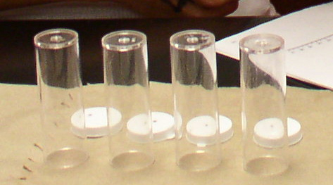  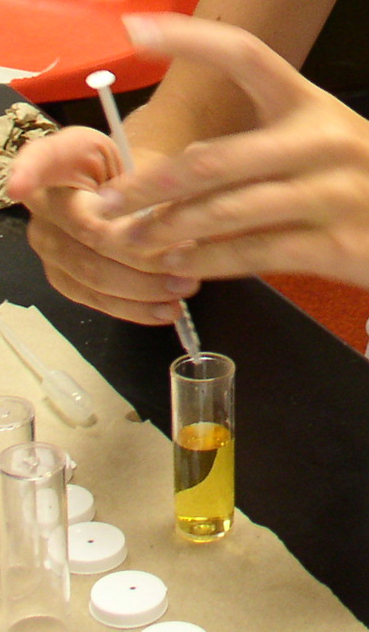  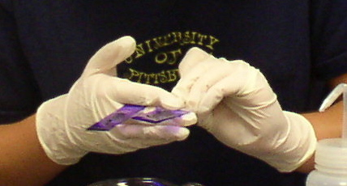  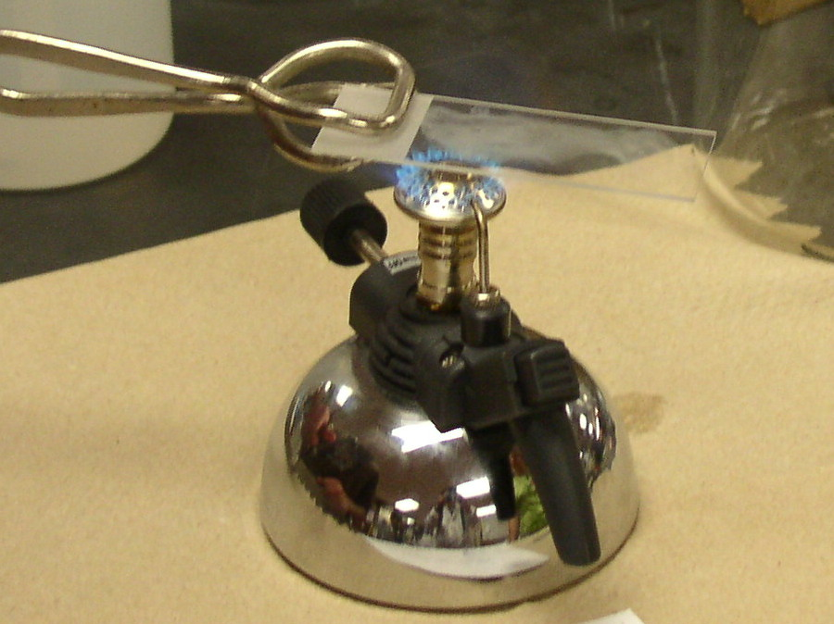  AP Biology  B  F  U  H  S  Innovations  in  Science  It all happens here!  AP Biology  B  F  U  H  S  Innovations  in  Science  It all happens here!  AP Biology  B  F  U  H  S  Innovations  in  Science  It all happens here!  AP Biology  B  F  U  H  S  Innovations  in  Science  It all happens here! |  |  |  |  | Concepts in Biology  Bellows Falls Union High School
Concepts in Biology
Bellows Falls Union High School
Innovations in Science  Concepts in Biology  Bellows Falls Union High School | Innovations in Science  Concepts in Biology  Bellows Falls Union High School

